Rainbow kids - Parents of Transgender and Gender Non-Conforming Kids

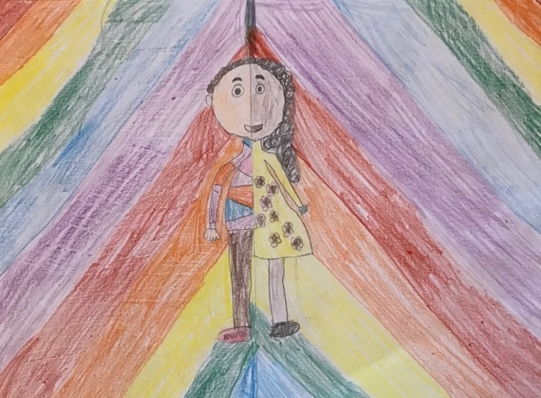

Welcome! We are a private facebook group designed for parents of children aged 3 to 12, who do not conform to standard gender norms, including transgender, gender-non conforming and however colorful other way your child expresses themselve.

Our group has two goals. 1. To provide a safe space for gender non-conforming kids to establish lasting relationships, play and have fun with like-minded friends in a playdate setting and 2. To create a space, both on facebook and in person for parents to exchange information, experiences and advice. Most importantly, we want to provide each other with emotional and mental support during this beautiful and at times difficult journey.

This group meets once a month in person. Date, time and location are regularly posted on the facebook page. The location varies, but provides a playroom/area where the kids can play, have fun and interact with each other under the supervision of one parent or an older sibling volunteer. Siblings are welcome as well. It also provides a separate room, where parents meet simultaneously in private to offer each other advice, experiences and information about parenting gender non-conforming kids. We lead our own discussions on topics such as concerns about safety, frustrations about family members not ‘getting it’, how to support our child through social transition, how to advocate in schools and whatever is on your heart and mind that day. We often start by going around the group and sharing our stories. Most importantly, we offer each other mental and emotional support in often trying and very lonely times.

New parents who are struggling to support and accept their children’s gender identity and would like to talk to other families in similar situations are welcome and encouraged to contact us.

This group is secret and by invitation only. We carefully vet new members to ensure their needs align with our group, that members are serious and participate honestly and to prevent trolls from joining.

Rainbow kids was established in the summer of 2018. It is modeled after ‘Stepping Stones’ a similar secret facebook group based in NYC (with their permission). We hope to grow and establish a loving, supporting environment for parents and kids alike.

If you like to join or have questions, please contact the admins at rainbowkids789@gmail.com

We are looking forward to hear from you!

